**[NATIONAL INSTITUTE OF TECHNOLOGY SILCHAR](http://www.nits.ac.in/)** [](http://www.nits.ac.in/)

**[राष्ट्रीय प्रौद्योगिकी संस्थान सिलचर](http://www.nits.ac.in/)**

**Project Report on Rumour Detection**

**Subject**:- Complex Network

**Subject Code** :- CS-1541

**Name** :- Shiva Agarwal

**Scholar Id** :- 2022111

**Department** :- Computer Science and Engineering

**Semester** :- Second

**Programme** :- M.Tech

**Email id** :- [shivaagarwal793@gmail.com](mailto:shivaagarwal793@gmail.com)

[shiva_pg@cse.nits.ac.in](mailto:shiva_pg@cse.nits.ac.in)

**Mobile** :- 7055791671(whatsapp) ,7017380062(Calling)

**Submitted to**

**Dr. Anupam Bishwas Sir**

**Details of Research Paper For Project**

1. Chen, T., Li, X., Yin, H. and Zhang, J., 2018, June. Call attention to rumors: Deep attention based recurrent neural networks for early rumor detection. In *Pacific-Asia conference on knowledge discovery and data mining* (pp. 40-52). Springer, Cham.
2. Guo, H., Cao, J., Zhang, Y., Guo, J. and Li, J., 2018, October. Rumor detection with hierarchical social attention network. In *Proceedings of the 27th ACM International Conference on Information and Knowledge Management* (pp. 943-951).
3. Huang, Z., Xu, W. and Yu, K., 2015. Bidirectional LSTM-CRF models for sequence tagging. *arXiv preprint arXiv:1508.01991*.
4. Greff, K., Srivastava, R.K., Koutník, J., Steunebrink, B.R. and Schmidhuber, J., 2016. LSTM: A search space odyssey. *IEEE transactions on neural networks and learning systems*, *28*(10), pp.2222-2232.
5. Habib, A., Akbar, S., Asghar, M.Z., Khattak, A.M., Ali, R. and Batool, U., 2018, November. Rumor detection in business reviews using supervised machine learning. In *2018 5th International Conference on Behavioral, Economic, and Socio-Cultural Computing (BESC)* (pp. 233-237). IEEE.
6. Ma, J., Gao, W. and Wong, K.F., 2018. Rumor detection on twitter with tree-structured recursive neural networks. Association for Computational Linguistics.
7. Kotteti, C.M.M., Dong, X. and Qian, L., 2018, December. Multiple time-series data analysis for rumor detection on social media. In *2018 IEEE International Conference on Big Data (Big Data)* (pp. 4413-4419). IEEE.
8. Jin, Z., Cao, J., Guo, H., Zhang, Y. and Luo, J., 2017, October. Multimodal fusion with recurrent neural networks for rumor detection on microblogs. In *Proceedings of the 25th ACM international conference on Multimedia* (pp. 795-816).
9. Bahuleyan, H. and Vechtomova, O., 2017, August. UWaterloo at SemEval-2017 Task 8: Detecting stance towards rumours with topic independent features. In *Proceedings of the 11th International Workshop on Semantic Evaluation (SemEval-2017)* (pp. 461-464).
10. Jin, Z., Cao, J., Guo, H., Zhang, Y. and Luo, J., 2017, October. Multimodal fusion with recurrent neural networks for rumor detection on microblogs. In *Proceedings of the 25th ACM international conference on Multimedia* (pp. 795-816).

**Details For System Requirements**

1. Hardware Requirements

* CPU = Core i3 OR higher
* RAM = 8 GB OR higher
* HDD = 256 GB OR higher

1. Software Requirements

* Operating System = Windows 10
* Python
* Jupyter Notebook
* Google Chrome
* Tensorflow
* Sklearn
* Pandas
* Numpy
* Seaborn
* Matplotlib
* Plotly
* Nkld
* Re
* String
* Google Colab on Google Chrome

1. Data Set :- https://www.kaggle.com/c/fake-news/data

**Analysis Of Project And Detail Instruction To Run the Project.**

1. Install all the software required, download from internet and run them and install on your machine. List of software is given Below.

* Python
* Jupyter Notebook
* Google Chrome

1. There are all the library that can be install on your machine by using command prompt. For example you want to install Tensorflow just type pip install tensorflow. Same for rest do it.

* Tensorflow
* Sklearn
* Pandas
* Numpy
* Seaborn
* Matplotlib
* Plotly
* Nkld
* Re
* String

1. Download the data set form the link provided above.
2. Now create a folder and paste true.csv and false.csv in that folder.
3. Now paste the file that provided in the zip file

* Rumour detection using lstm
* Rumour detection

1. Run jupyter notebook on that folder.
2. Now run each and every cell of that to get output.

**Working OF LSTM Model**

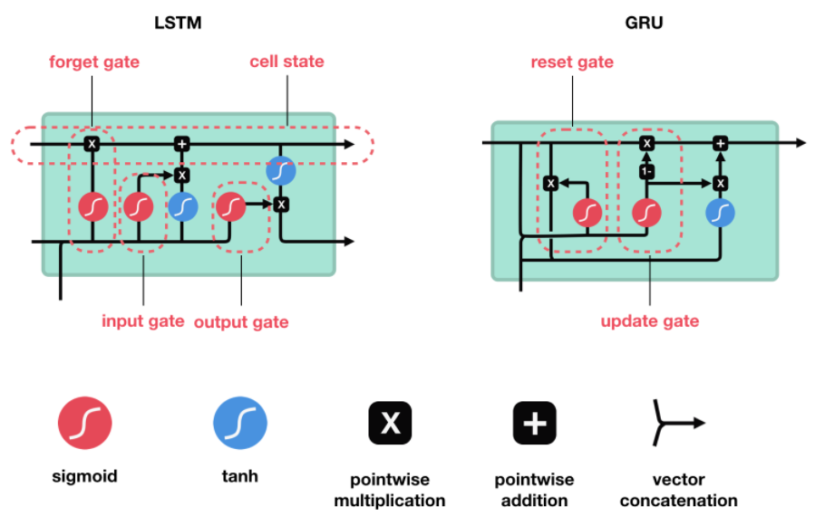

At first, we are going to develop the base model and compile it. The first layer will be the embedding layer which has the input of vocabulary size, vector features, and sentence length. Later we add a 30% dropout layer to prevent overfitting and the LSTM layer which has 100 neurons in the layer. In the final layer, we use the sigmoid activation function. Later we compile the model using adam optimizer and binary cross-entropy as loss function since we have only two outputs.